Module 2: Running DLMtool

Tom Carruthers, Adrian Hordyk

## Exercise 2b: A basic DLMtool run

### Finding Alternative Stock, Fleet, and Observation objects

Use the avail function to find the built-in Stock, Fleet, and Observation objects. How many of each object type are built into DLMtool?

### Building an Operating Model

Use the new function to build a operating model with Stock: Blue_shark, Fleet: IncE_NDom, and Observation: Imprecise_Unbiased and write the OM object to a variable called myOM.

**Plot OM Object Function still being added to DLMtool** Examine the myOM object using the plotOM function.

### Run a Quick MSE

For this example MSE we will select 7 output control MPs to test:

MPs=c("AvC", "BK", "DAAC", "DCAC", "DepF", "DynF", "HDAAC")

Use the runMSE function to run a MSE using the following command:

myMSE <- runMSE(myOM, MPs)

### Examine the MSE

Use the Tplot function to examine performance and trade-offs in the MSE using pre-specified performance metrics.

Which MP would you select as the best performing?

Tplot(myMSE)

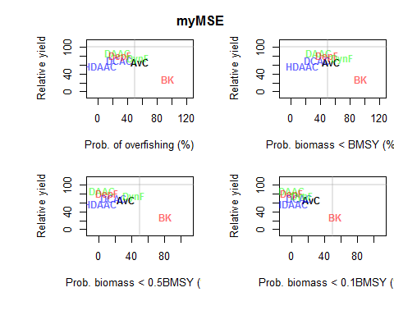

Examine the MSE object using other plotting functions.

Tip: you can use the plotFun() function to print out DLMtool functions for plotting MSE objects.